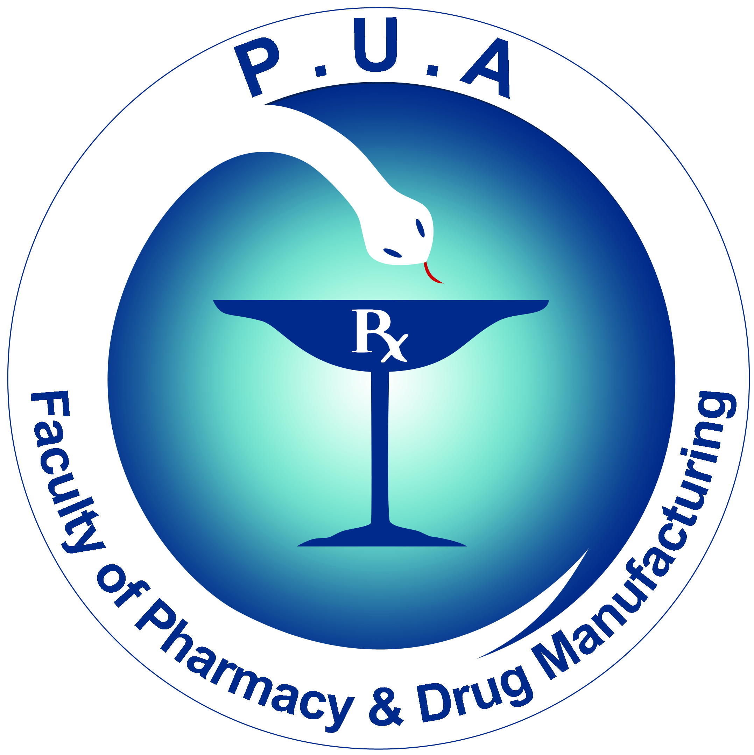
Faculty of Pharmacy
& Drug Manufacturing
Department of Pharmaceutical Chemistry

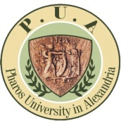
Pharos University

جامـــعة فــاروس

PCD 105 Pharmaceutical Analytical Chemistry II
Week 4 lectures

Due to the second international conference in pharmaceutical sciences organized by Faculty of Pharmacy and Drug Manufacturing held on 11th and 12th of March 2020, week 4 lectures will be held on Saturday 7th of March from 10:30 in C 118 and Tuesday 10th of March from 8:30 in C614.

