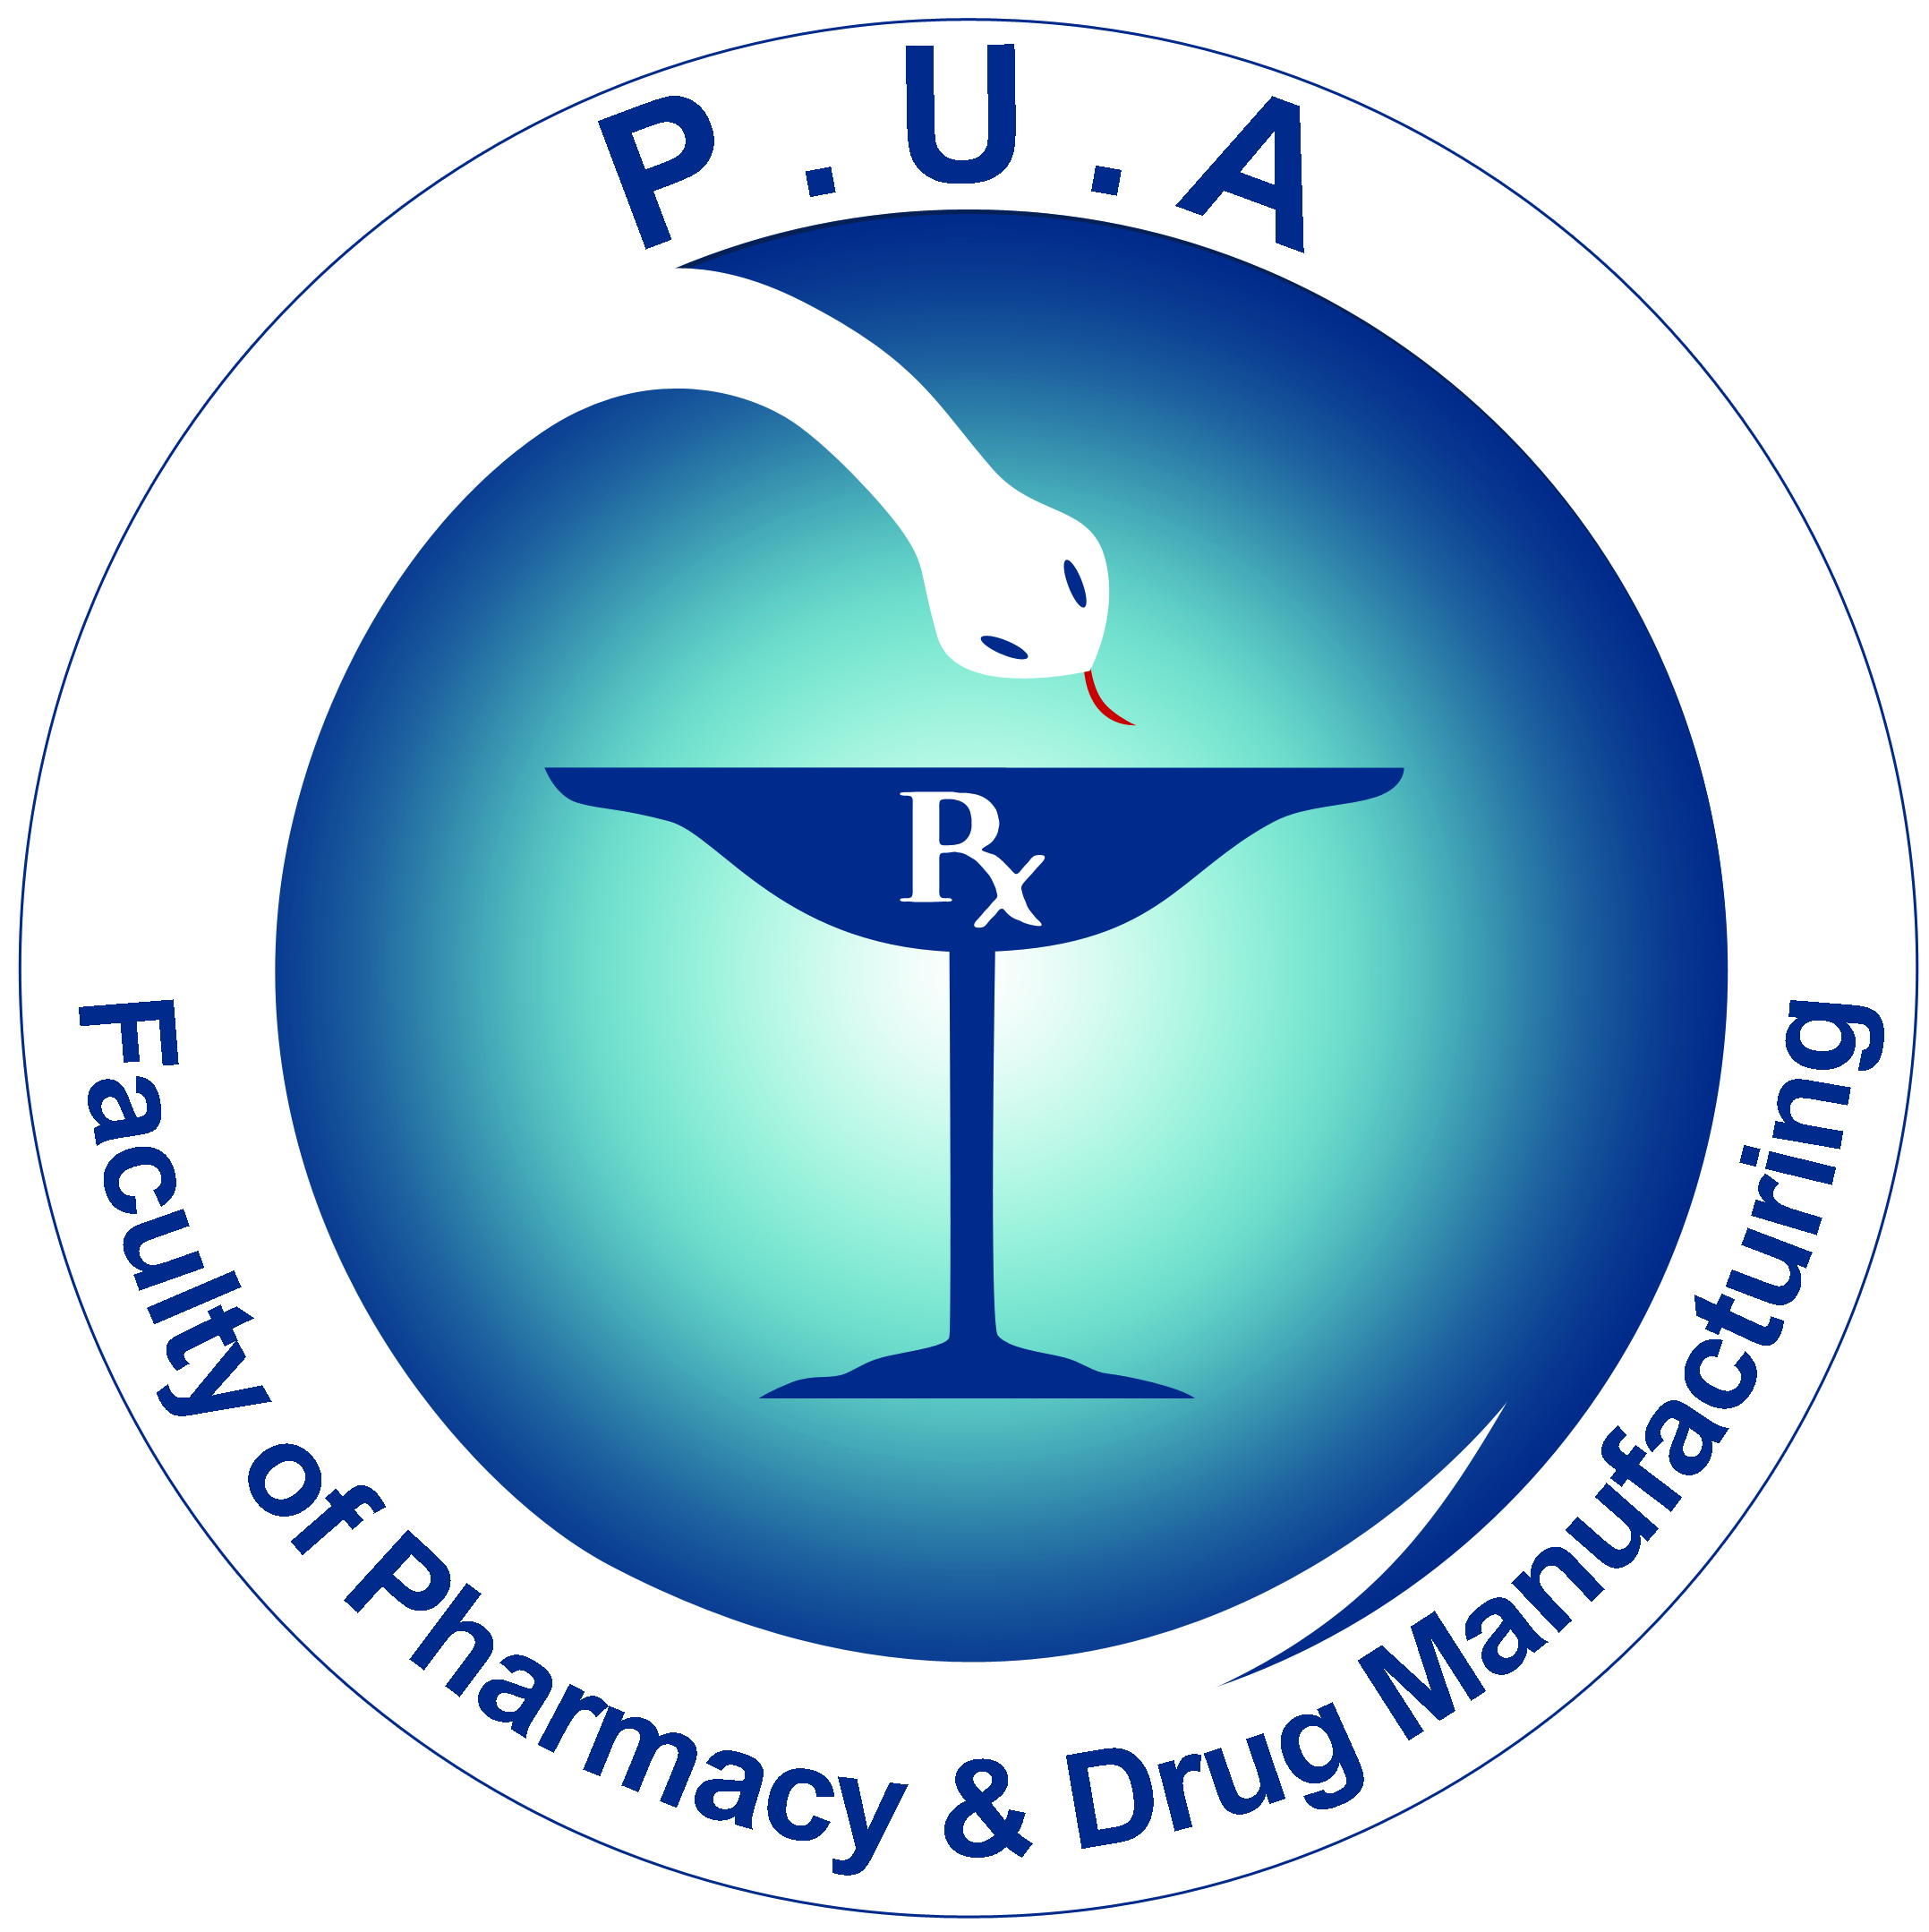
Faculty of Pharmacy
& Drug Manufacturing
Department of Pharmaceutical Chemistry

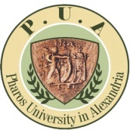
Pharos University

جامـــعة فــاروس

PCD 105 Pharmaceutical Analytical Chemistry II
Week 2 lectures

Due to the weather conditions and cancellation of Tuesday’s lecture and that students are not yet assigned to groups, students attending lectures on Tuesday will attend the lecture on Thursday in C 214 from 10:30 with Thursday students.

