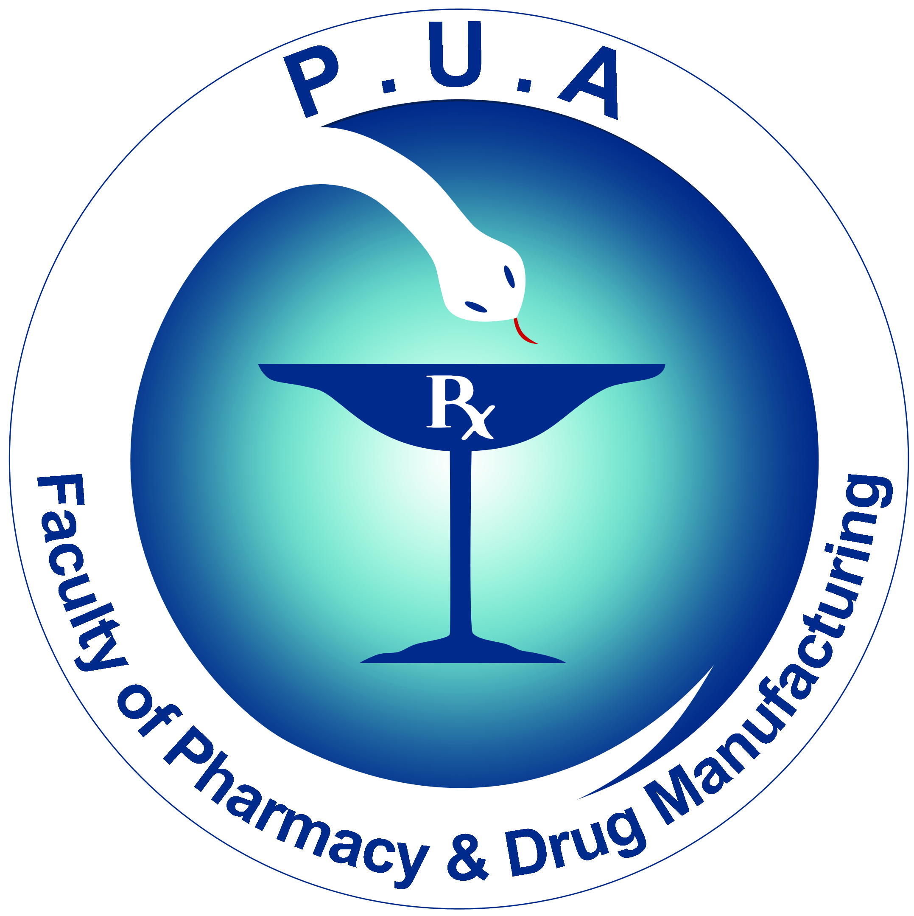
Faculty of Pharmacy
& Drug Manufacturing
Department of Pharmaceutical Chemistry

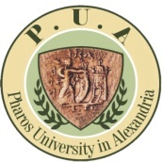
Pharos University

جامـــعة فــاروس

PCD 105 Pharmaceutical Analytical Chemistry II

Lectures Notes and Practical Notes are available in the University Copy Center. They must be available with you in the lecture and practical sessions.

